# Question17 Design non-relational cloud data stores

Case Study

Complete the Case Study

* Solution Evalutation
* **Instructions**This case study contains a series of questions that present the same scenario. Each question in the series contains a unique solution that might meet the stated goals. Some question sets might have more than one correct solution, while others might not have a correct solution.  
    
  Note: You cannot go back or review questions of this type on the actual certification exam.
* Data Model

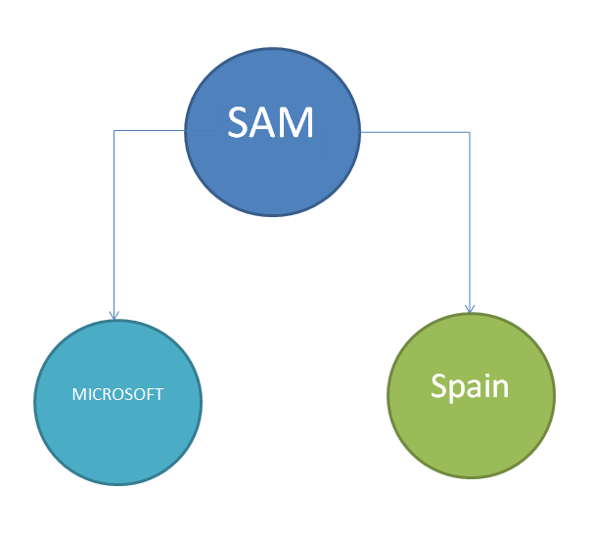

## Question 17.1

You are a data architect for your company.  The company's application development team is upgrading an application and migrating it to the cloud. The current application uses a graph data model that represents data as vertices and edges, as shown in the Data Model exhibit.  
  
You need to choose a cloud data store for the model.  
  
Solution: You choose Azure Cosmos DB with the Table API.  
  
Does this solution meet the goal?

Complete the Case Study

* Solution Evalutation
* Data Model
* Question 1
* Question 2
* Question 3
* Question 4

Yes

No

## Question 17.2

You are a data architect for your company.  The company's application development team is upgrading an application and migrating it to the cloud. The current application uses a graph data model that represents data as vertices and edges, as shown in the Data Model exhibit.  
  
You need to choose a cloud data store for the model.  
  
Solution: You choose Azure Cosmos DB with the Gremlin API.  
  
Does this solution meet the goal?

Complete the Case Study

* Solution Evalutation
* Data Model
* Question 1
* Question 2
* Question 3
* Question 4

Yes

No

## Question 17.3

You are a data architect for your company.  The company's application development team is upgrading an application and migrating it to the cloud. The current application uses a graph data model that represents data as vertices and edges, as shown in the Data Model exhibit.  
  
You need to choose a cloud data store for the model.  
  
Solution: You choose Azure Cosmos DB with the SQL API.  
  
Does this solution meet the goal?

Complete the Case Study

* Solution Evalutation
* Data Model
* Question 1
* Question 2
* Question 3
* Question 4

Yes

No

## Question 17.4

You are a data architect for your company.  The company's application development team is upgrading an application and migrating it to the cloud. The current application uses a graph data model that represents data as vertices and edges, as shown in the Data Model exhibit.  
  
You need to choose a cloud data store for the model.  
  
Solution: You choose Azure Cosmos DB with the MongoDB API.  
  
Does this solution meet the goal?

Complete the Case Study

* Solution Evalutation
* Data Model
* Question 1
* Question 2
* Question 3
* Question 4

Yes

No

# Question21 Design non-relational cloud data stores

Case Study

Complete the Case Study

* Solution Evaluation
* Question 1
* Question 2
* Question 3

**Instructions**  
  
This case study contains a series of questions that present the same scenario. Each question in the series contains a unique solution that might meet the stated goals. Some question sets might have more than one correct solution, while others might not have a correct solution.  
  
Note: You cannot go back or review questions of this type on the actual certification exam.

## Question 21.1

You are a data architect for your company. Your company manages data from customers all over the world. Each customer supplies your company with data in a variety of formats. Your company must transform the data after it receives it. The total size of all customer data is under one pebibyte (PiB).  
  
You need to recommend a data storage solution for customer data.  
  
Solution: You recommend Azure Table storage.  
  
Does this solution meet the goal?

Complete the Case Study

* Solution Evaluation
* Question 1
* Question 2
* Question 3

Yes

No

## Question 21.2

You are a data architect for your company. Your company manages data from customers all over the world. Each customer supplies your company with data in a variety of formats. Your company must transform the data after it receives it. The total size of all customer data is under one pebibyte (PiB).  
  
You need to recommend a data storage solution for customer data.  
  
Solution: You recommend Azure Blob storage.  
  
Does this solution meet the goal?

Complete the Case Study

* Solution Evaluation
* Question 1
* Question 2
* Question 3

Yes

No

## Question 21.3

You are a data architect for your company. Your company manages data from customers all over the world. Each customer supplies your company with data in a variety of formats. Your company must transform the data after it receives it. The total size of all customer data is under one pebibyte (PiB).  
  
You need to recommend a data storage solution for customer data.  
  
Solution: You recommend Azure Data Lake.  
  
Does this solution meet the goal?

Complete the Case Study

* Solution Evaluation
* Question 1
* Question 2
* Question 3

Yes

No

# Question24 Design non-relational cloud data stores

Case Study

Complete the Case Study

* Solution Evaluation
* **Instructions**  
    
  This case study contains a series of questions that present the same scenario. Each question in the series contains a unique solution that might meet the stated goals. Some question sets might have more than one correct solution, while others might not have a correct solution.  
    
  Note: You cannot go back or review questions of this type on the actual certification exam.
* Sample Data

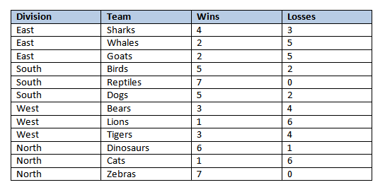

## Question 24.1

You are a data architect. You are designing a data solution to manage statistics for a world-wide sports league. You plan to store the data in an Azure table. Every team in the league has a unique name, and each team is part of a division. There are a total of four divisions. The statistics keep track of the wins and losses for each team in the division. Sample data is shown in the Sample Data exhibit. The production table will contain over 4,000 rows.  
  
You need to recommend an appropriate partition key.  
  
Solution: You choose Division as the partition key.  
  
Does this solution meet the goal?

Complete the Case Study

* Solution Evaluation
* Sample Data
* Question 1
* Question 2
* Question 3
* Question 4

No

Yes

## Question 24.2

You are a data architect. You are designing a data solution to manage statistics for a world-wide sports league. You plan to store the data in an Azure table. Every team in the league has a unique name, and each team is part of a division. There are a total of four divisions. The statistics keep track of the wins and losses for each team in the division. Sample data is shown in the Sample Data exhibit. The production table will contain over 4,000 rows.  
  
You need to recommend an appropriate partition key.  
  
Solution: You choose Team as the partition key.  
  
Does this solution meet the goal?

Complete the Case Study

* Solution Evaluation
* Sample Data
* Question 1
* Question 2
* Question 3
* Question 4

No

Yes

## Question 24.3

You are a data architect. You are designing a data solution to manage statistics for a world-wide sports league. You plan to store the data in an Azure table. Every team in the league has a unique name, and each team is part of a division. There are a total of four divisions. The statistics keep track of the wins and losses for each team in the division. Sample data is shown in the Sample Data exhibit. The production table will contain over 4,000 rows.  
  
You need to recommend an appropriate partition key.  
  
Solution: You choose Wins as the partition key.  
  
Does this solution meet the goal?

Complete the Case Study

* Solution Evaluation
* Sample Data
* Question 1
* Question 2
* Question 3
* Question 4

Yes

No

## Question 24.4

You are a data architect. You are designing a data solution to manage statistics for a world-wide sports league. You plan to store the data in an Azure table. Every team in the league has a unique name, and each team is part of a division. There are a total of four divisions. The statistics keep track of the wins and losses for each team in the division. Sample data is shown in the Sample Data exhibit. The production table will contain over 4,000 rows.  
  
You need to recommend an appropriate partition key.  
  
Solution: You choose Losses as the partition key.  
  
Does this solution meet the goal?

Complete the Case Study

* Solution Evaluation
* Sample Data
* Question 1
* Question 2
* Question 3
* Question 4

No

Yes

# Question28 Design non-relational cloud data stores

Case Study

Complete the Case Study

* Scenario Evaluation
* Question 1
* Question 2
* Question 3

**Instructions**  
  
This case study contains a series of questions that present the same scenario. Each question in the series contains a unique solution that might meet the stated goals. Some question sets might have more than one correct solution, while others might not have a correct solution.  
  
Note: You cannot go back or review questions of this type on the actual certification exam.

## Question 28.1

You are designing an HDInsight application with a clustered Apache Hadoop file system that uses Azure Data Lake Gen1 storage. The application design specifies the following requirements:

* Azure Active Directory (Azure AD) multi-factor authentication (MFA)
* Access control through POSIX permissions
* Support for auditing through diagnostics logging
* Automatic data encryption before persistent storage

You need to configure your solution to optimize storage performance.  
  
Solution: You batch process files into file sizes of at least 256 MB before writing to Data Lake Storage Gen1.  
  
Does this solution meet the goal?

Complete the Case Study

* Scenario Evaluation
* Question 1
* Question 2
* Question 3

No

Yes

## Question 28.2

You are designing an HDInsight application with a clustered Apache Hadoop file system that uses Azure Data Lake Gen1 storage. The application design specifies the following requirements:

* Azure Active Directory (Azure AD) multi-factor authentication (MFA)
* Access control through POSIX permissions
* Support for auditing through diagnostics logging
* Automatic data encryption before persistent storage

You need to configure your solution to optimize storage performance.  
  
Solution: You preprocess files to ensure that they are smaller than 256 MB before writing to Data Lake Storage Gen1.  
  
Does this solution meet the goal?

Complete the Case Study

* Scenario Evaluation
* Question 1
* Question 2
* Question 3

No

Yes

## Question 28.3

You are designing an HDInsight application with a clustered Apache Hadoop file system that uses Azure Data Lake Gen1 storage. The application design specifies the following requirements:

* Azure Active Directory (Azure AD) multi-factor authentication (MFA)
* Access control through POSIX permissions
* Support for auditing through diagnostics logging
* Automatic data encryption before persistent storage

You need to configure your solution to optimize storage performance.  
  
Solution: You implement compaction jobs to combine smaller files into files that are 2 GB in size or larger.  
  
Does this solution meet the goal?

Complete the Case Study

* Scenario Evaluation
* Question 1
* Question 2
* Question 3

No

Yes

# Question31 Design non-relational cloud data stores

Case Study

Complete the Case Study

* Overview

You are the database administrator for CompanyA. The company is a reseller of internet information about financial and distribution markets. The company is planning an investment into Azure and is looking for the right type of data platform to be able to consume data from all the various incoming data feeds. The feeds consist of a variety of formats including CSV files, JSON documents, XML files and others. The data is presently copied to Azure using a custom script.  
  
The company wants to find the simplest way to ingest the data, transform it into a relational format, and make it readily available for consumers to view as well as ensuring efficient query latency.

## Question 31.1

What type of data platform in Azure should be used as the initial destination of the incoming data feeds?

Complete the Case Study

* Overview
* Question 1
* Question 2
* Question 3
* Question 4

Azure SQL Database

Azure Synapse

Azure Data Lake

Azure PolyBase

## Question 31.2

What solution should you use to transform the data from the various formats and import the data into a relational platform?

Complete the Case Study

* Overview
* Question 1
* Question 2
* Question 3
* Question 4

Azure PolyBase

Azure Data Lake

Azure Synapse Analytics

Azure Data Factory

## Question 31.3

For the final step in the processing of the data, you need to select the right destination Azure repository for the transformed data.  
  
Which destination should you use?

Complete the Case Study

* Overview
* Question 1
* Question 2
* Question 3
* Question 4

Azure Data Factory

Azure Data Lake

Azure Synapse

Azure PolyBase

## Question 31.4

The company wants to automate the copying of data feeds to Azure to gain more efficiency and bring the data to their users faster.  
  
What Azure service or component should the company use to move the data from on-premises to Azure?

Complete the Case Study

* Overview
* Question 1
* Question 2
* Question 3
* Question 4

Azure PolyBase

Azure DataFactory

Azure Synapse

Azure Data Lake

# Question35 Design non-relational cloud data stores

Case Study

Complete the Case Study

* Solution Evaluation

**Instructions**  
  
This case study contains a series of questions that present the same scenario. Each question in the series contains a unique solution that might meet the stated goals. Some question sets might have more than one correct solution, while others might not have a correct solution.  
  
Note: You cannot go back or review questions of this type on the actual certification exam.

## Question 35.1

You are a data scientist at CompanyB. The company has a strict policy of not allowing inbound network connectivity from the internet or allowing outbound connectivity over anything except HTTP/HTTPS. You want to use Azure DataBricks to transform your on-premises data and collaborate and share visualizations with partners in other companies.  
  
You need to recommend a solution to copy the data to a location where Azure DataBricks can be used to process it.  
  
Solution: Use a self-hosted Integration Runtime (IR).  
  
Does this solution meet the goal?

Complete the Case Study

* Solution Evaluation
* Question 1
* Question 2
* Question 3

No

Yes

## Question 35.2

You are a data scientist at CompanyB. The company has a strict policy of not allowing inbound network connectivity from the internet or allowing outbound connectivity over anything except HTTP/HTTPS. You want to use Azure DataBricks to transform your on-premises data and collaborate and share visualizations with partners in other companies.  
  
You need to recommend a solution to copy the data to a location where Azure DataBricks can be used to process it.  
  
Solution: Use an Azure-SSIS Integration Runtime.  
  
Does this solution meet the goal?

Complete the Case Study

* Solution Evaluation
* Question 1
* Question 2
* Question 3

No

Yes

## Question 35.3

You are a data scientist at CompanyB. The company has a strict policy of not allowing inbound network connectivity from the internet or allowing outbound connectivity over anything except HTTP/HTTPS. You want to use Azure DataBricks to transform your on-premises data and collaborate and share visualizations with partners in other companies.  
  
You need to recommend a solution to copy the data to a location where Azure DataBricks can be used to process it.  
  
Solution: Use an Azure Integration Runtime.  
  
Does this solution meet the goal?

Complete the Case Study

* Solution Evaluation
* Question 1
* Question 2
* Question 3

Yes

No

# Question38 Design non-relational cloud data stores

Case Study

Complete the Case Study

* Overview

You are a data scientist for CompanyC, which is a very large retail company.  
  
You are asked to help manage reordering the most popular products. The company allows the managers of franchised locations to use their own delimited text formats for submitting sales. At a minimum, they must include the current date, item stock keeping unit (SKU) number, price, and sales quantity.  
  
CompanyC has had issues with manual ordering processes and wants you to assist with sales forecasting, inventory management, and stock control.  
  
Overall, the plan is to reduce the net Cost Of Goods sold (COGS) over time. Ten years of historical sales data with over a billion records in total must be viewable graphically via dashboards.

## Question 38.1

What solution should you choose to store the initial intake of data?

Complete the Case Study

* Overview
* Question 1
* Question 2
* Question 3
* Question 4

Azure Synapse Analytics

Azure Data Lake

Power BI

Azure PolyBase

## Question 38.2

What solution should you use to convert the different incoming data formats to a normalized relational format?

Complete the Case Study

* Overview
* Question 1
* Question 2
* Question 3
* Question 4

Azure Synapse Analytics

Azure PolyBase

Azure Data Lake

Power BI

## Question 38.3

What platform should you use to support historical data queries?

Complete the Case Study

* Overview
* Question 1
* Question 2
* Question 3
* Question 4

Power BI

Azure Data Lake

Azure Synapse Analytics

Azure PolyBase

## Question 38.4

What solution should you use for visualizing the data by using dashboards?

Complete the Case Study

* Overview
* Question 1
* Question 2
* Question 3
* Question 4

Power BI

Azure Data Lake

Azure PolyBase

Azure Synapse Analytics

# Question79 Design non-relational cloud data stores

You are designing the storage requirements for your company's automatic process tracking system. IoT sensors scan components at various points in the automated manufacturing process and record the product number, serial number, time, and manufacturing line location. Several hundred pieces are scanned by each sensor each day.  
  
Sensor data is written to a Cosmos DB account in a collection named Tracking. The insertion rate for tracking data must be maximized. Data should be partitioned to optimize organizing information by part type.  
  
You need to configure the default consistency level and partition key property.  
  
What configuration should you use? To answer, select the appropriate values from the drop-down menus.

Choose the correct options

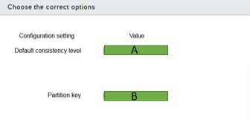

A)

1. Strong
2. Bonded stateless
3. Session
4. Consistent prefix
5. eventual

B)

1. Serial number
2. Time
3. Line location
4. Product number

# Question80 Design non-relational cloud data stores

You are designing a database solution for an application under development. You plan to use Cosmos DB for data storage. The application requires graph database model support.  
  
You need to choose the appropriate Cosmos DB API.  
  
Which one should you choose?

Choose the correct answer

MongoDB API

Gremlin API

Cassandra API

SQL API

# Question81 Design non-relational cloud data stores

You are asked to design a database solution to support a low-latency global application. You plan to use Cosmos DB as the Azure solution.  
  
You need to choose a consistency level that supports the lowest possible Recovery Point Objective (RPO) and a Recovery Time Objective (RTO) of no more than 15 minutes for a multiple region outage.  
  
Which consistency level should you use?

Choose the correct answer

Bounded staleness

Consistent prefix

Strong

Session

# Question82 Design non-relational cloud data stores

You are designing your company's datastore retention policies. Items uploaded to the company’s Cosmos DB data store are retained for only 24 hours unless they have a specific retention policy override set.   
  
You need to plan the correct Time to Live policy for the database design. The design must require the least administrative intervention from the solution admins once it is deployed.  
  
What policy should you include in the design?

Choose the correct answer

Set the DefaultTimeToLive to 24.

Set the TimeToLive to 86400.

Set the TimeToLive to 24.

Set the DefaultTimeToLive to -1.

Set the DefaultTimeToLive to 86400.

# Question83 Design non-relational cloud data stores

You are asked to design a solution that uses a trigger to read blob storage contents and writes them to a new Cosmos DB document overnight. The items are uploaded to blob storage during the daily working hours of 8 A.M. to 9 P.M.  
  
You need to choose the trigger type that requires the least custom functionality to meet the requirements.  
  
What Azure trigger type should you choose?

Choose the correct answer

Timer

Queue

Event Grid

HTTP

# Question84 Design non-relational cloud data stores

You are designing your company’s Cosmos DB platform. The applications that use the data store are distributed globally. Users need fast access to the latest version of each other's data. Users are performing write operations through the 24-hour day.  
  
Applications querying the data must have the lowest latency possible. Results returned to the application in the non-primary region can have missing data that has not yet replicated but cannot have out-of-order data.   
  
You need to choose the consistency level to meet the requirements.  
  
Which consistency level should you use?

Choose the correct answer

Consistent prefix

Bounded staleness

Eventual

Session

# Question85 Design non-relational cloud data stores

You are designing your company’s Cosmos DB platform to support a globally distributed application. Responses to queries to the data store do not need to return the very latest version of a record. You want to have a flexible configuration model for the data with respect to how up-to-date the responses to read requests from applications are. Responses should be configurable by the number of item versions and the time interval between reads and writes.  
  
You need to choose a consistency level to meet the requirements.  
  
Which consistency level should you use?

Choose the correct answer

Session

Eventual

Consistent prefix

Bounded staleness

# Question86 Design non-relational cloud data stores

You are designing the partitioning methodology for an Azure Synapse Analytics solution.  
  
One of your fact tables has more than 2 billion rows and must contain a maximum of 37 months of sales data. Month 37 is deleted at the end of each month. Extract, Transform, and Load (ETL) processes will be used to insert data to the main fact table, which contains the following column names and data types:  
  
ProductNumber of type BigInt  
OrderDate of type Date  
OrderQuantity of type BigInt  
UnitPrice of type Decimal  
TotalSale of Type Decimal  
  
You need to design the most appropriate way to partition across this data.  
  
Which column should you use?

Choose the correct answer

ProductNumber

TotalSale

OrderDate

OrderQuantity

UnitPrice

# Question87 Design non-relational cloud data stores

You are building out the mapping data flow for an Azure Data Factory transformation.  
  
You need to route rows of data to different streams based on rule matches against that data. The routing of data should follow only the first successfully resolved rule and not all rules.  
  
Which mapping data flow transformation should you select?

Choose the correct answer

Conditional split

Filter

New branch

Unpivot

# Question88 Design non-relational cloud data stores

You are helping a large retail company with managing reordering of their most popular products, sales forecasting, inventory management, and stock control.  
  
The company allows the managers of its franchise to use their own formats for submitting sales. These must include the current date, item stock keeping unit (SKU) number, price, and sales quantity.  
  
The company wants to reduce the net Cost Of Goods sold (COGS) over time. Ten years of historical sales data must be viewable graphically via dashboards.  
  
You need to propose a solution for storing the initial intake of data.  
  
What should you use?

Choose the correct answer

Azure PolyBase

Azure Synapse

Power BI

Azure Data Lake

# Question92 Design non-relational cloud data stores

You are setting up storage support for an application that uses Azure Data Lake Storage Gen2. A primary concern is disaster recovery.  
  
You need to implement a disaster recovery solution that helps to ensure recovery after a catastrophic event resulting in widespread failure throughout a region.  
  
What should you use?

Choose the correct answer

Geo-replication

Locally redundant storage (LRS)

Zone redundant storage (ZRS)

Geo-redundant storage (GRS)

# Question94 Design non-relational cloud data stores

You are a data architect for your company. You plan to deploy two Azure Cosmos DB accounts. The accounts must meet the following requirements:

* CosmosDB1 -  You want to configure the time by which reads can lag behind writes.
* CosmosDB2 -  You want to ensure that each client application reads the same values that it wrote with minimal latency.

You need to choose the most appropriate consistency level for each account.  
  
Which consistency levels should you use? To answer, drag the appropriate consistency level to each Cosmos DB account. Each consistency level may be used once, more than once, or not at all.

Drag and drop the answers

https://pts.measureup.com/web/instances/MUP/assets/images/DP-201/DP-201_64023/session(2).png

https://pts.measureup.com/web/instances/MUP/assets/images/DP-201/DP-201_64023/bonded_staleness(2).png

https://pts.measureup.com/web/instances/MUP/assets/images/DP-201/DP-201_64023/session(2).png

https://pts.measureup.com/web/instances/MUP/assets/images/DP-201/DP-201_64023/bonded_staleness(2).png

https://pts.measureup.com/web/instances/MUP/assets/images/DP-201/DP-201_64023/eventual(2).png

https://pts.measureup.com/web/instances/MUP/assets/images/DP-201/DP-201_64023/consistent_prefix(2).png

https://pts.measureup.com/web/instances/MUP/assets/images/DP-201/DP-201_64023/strong(2).png

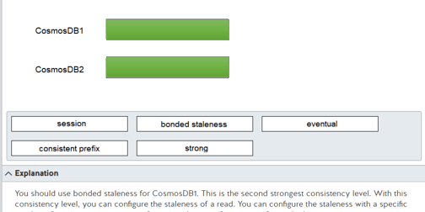

# Question127 Design non-relational cloud data stores

You are designing a processing solution based on Azure Functions. The manufacturing process and quality control data is collected and uploaded directly into Azure Blob Storage. You must design a solution that:

* Optimizes the processing of new data as it is loaded into blob storage.
* Dynamically scales resources to meet processing requirements.
* Minimizes costs.

You need to recommend the hosting plan and trigger type for the Azure function.  
  
Which hosting plan and trigger type should you recommend? To answer, select the correct configuration settings from the drop-down menus.

Choose the correct options

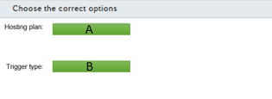

A)

1. App Service Plan
2. Consumption plan
3. Dedicated plan
4. Premium plan

B)

1. Blob Trigger
2. EvenGridTrigger
3. Queue Trigger

# Question140 Design non-relational cloud data stores

You are designing a Cosmos DB solution to support a global application. Your solution should minimize the following:

* Recovery point objective (RPO) - The time period of updates that you can afford to lose in case of regional failure.
* Recovery time objective (RTO) - The time to fully recover an application.

You need to configure a single master replication model across multiple regions to meet these requirements.  
  
Which consistency level should you configure?

Choose the correct answer

Eventual

Consistent prefix

Strong

Session

# Question157 Design non-relational cloud data stores

You are designing storage support for an HDInsight cluster with access to Azure Data Lake Gen1 storage. Your solution must support copying data between regions from Azure Storage Blob to Azure Data Lake Gen1. The solution must support copying update deltas only.  
  
You need to recommend a copy solution.  
  
What should you recommend?

Choose the correct answer

Distcp

AdlCopy

Sqoop

Azure Data Factory

# Question161 Design non-relational cloud data stores

You are a data architect for your company. You plan to deploy two Azure Cosmos DB accounts. The accounts must meet the following requirements:

* CosmosDB1 -  You want to achieve the highest availability and the lowest latency.
* CosmosDB2 -  You want to ensure that all client applications always read the same values.

You need to choose the most appropriate consistency level for each account.  
  
What consistency levels should you use? To answer, drag the appropriate consistency level to each Cosmos DB account. Each consistency level may be used once, more than once, or not at all.

Drag and drop the answers

https://pts.measureup.com/web/instances/MUP/assets/images/DP-201/DP-201_64021/strong.png

https://pts.measureup.com/web/instances/MUP/assets/images/DP-201/DP-201_64021/eventual.png

https://pts.measureup.com/web/instances/MUP/assets/images/DP-201/DP-201_64021/strong.png

https://pts.measureup.com/web/instances/MUP/assets/images/DP-201/DP-201_64021/eventual.png

https://pts.measureup.com/web/instances/MUP/assets/images/DP-201/DP-201_64021/session.png

https://pts.measureup.com/web/instances/MUP/assets/images/DP-201/DP-201_64021/consistent_prefix.png

https://pts.measureup.com/web/instances/MUP/assets/images/DP-201/DP-201_64021/bounded_staleness.png

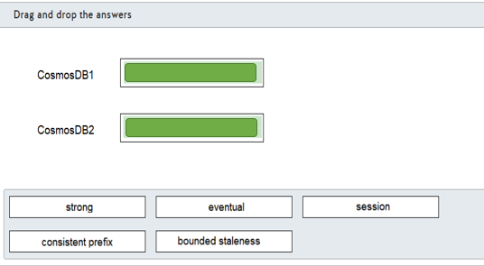

# Question170 Design non-relational cloud data stores

Performance for an on-premises data warehouse has degraded over time. You discover that the problem is related to two fact tables. Queries using the SalesHistory table take longer than expected to complete. Data loads into the invoice table often suffer performance issues and impact data processing. Both tables include related columns named SalesDate, ProductID, and RegionID.  
  
The SalesHistory table is approximately 1 TB in size and is used for several analysis purposes, including sales analysis and trend predictions. The SalesDate column is often used in queries, and the ProductID column is used extensively in JOIN operations. The RegionID is used for grouping results.  
  
The Invoice table is used primarily as a staging table with data loaded into Invoice before being processed and loaded into SalesHistory. The table size seldom exceeds 1 GB. Table content is processed daily by region with the RegionID used to group data.  
  
You are moving the on-premises data warehouse to Azure SQL Data Warehouse. You need to determine the distribution type and distribution column configurations that best meet your processing requirements. Total storage space requirements should be minimized.  
  
Which distribution types and columns should you use? To answer, select the appropriate options from the drop-down menus.

Choose the correct options

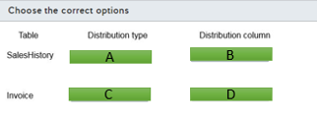

A)

1. Hash-distributed
2. Replicated
3. Round-robin

B)

1. ProductID
2. RegionID
3. SalesDate
4. None

C)

1. Hash-distributed
2. Replicated
3. Round-robin

D)

1. ProductID
2. RegionID
3. SalesDate
4. None